**UML DIAGRAM**

1. **Class Diagram**

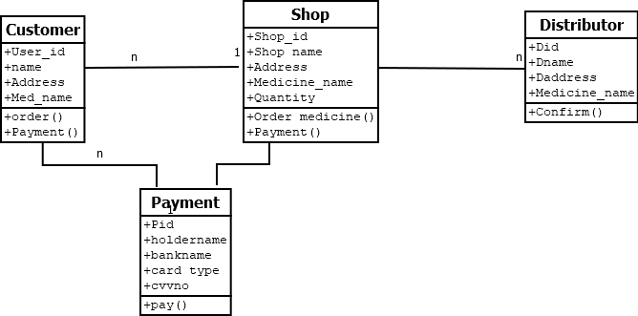

1. **Object Diagram**

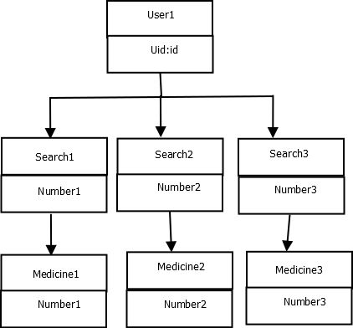

1. **Collabration Diagram**

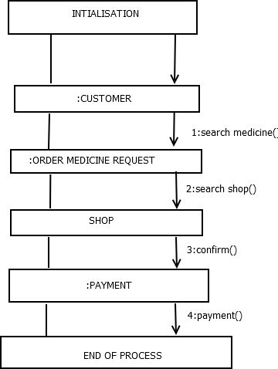

**4.Diployment Diagram**

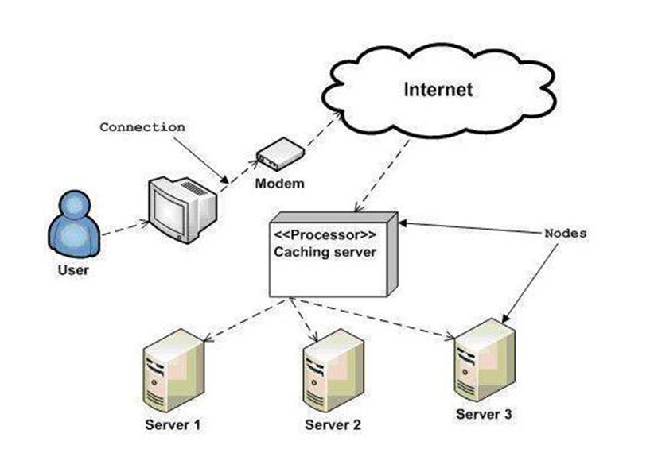

**5.Sequence Diagram**

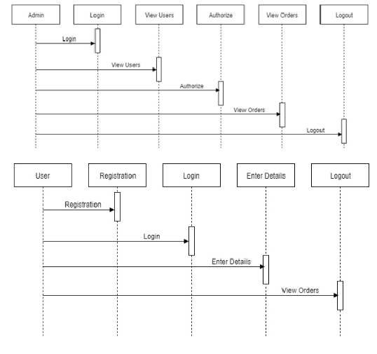

**6.Usecase Diagram**

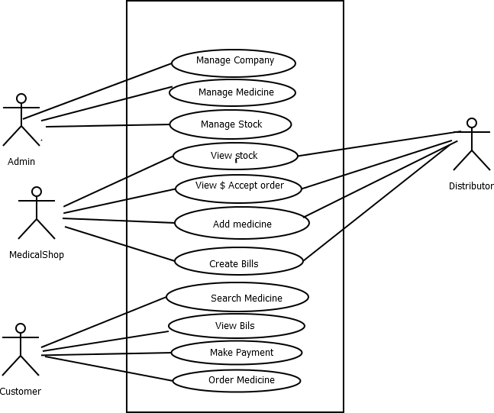

**7.Activity Diagram**

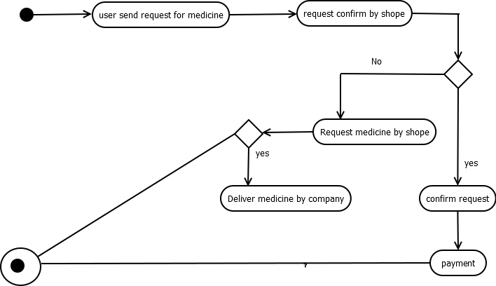

**Statechart Diagram**

